Welcome - Ms. Kelly

- Christmas song - Joy to the world

- The real true story of Rumpelstilskin
Original by the Brothers Grimm
Adapted by Mr. David and K, G.1 and G.2 students
- Crystal Palace Waltz (Piano solo)
G.5 Divya Venkataraman
- Many Princesses and One Pea
Original by Hans Christian Andersen
Adapted by Mr. David and G.4 students
- Group guitar – Jesus loves Me; Silent Night
G.1 Dheeraj Shah, G.3 Aadit Noronha, Jayadev Ghanta, Nishanth Joshi, Varsha Iyengar
Instructed by Dr. TC Lee
- Violin Solo
G.6 Avrav Noronha, accompany by Mr. Noronha
- Chinese Songs & Rhymes
K, G.1, G.2 and G.3 students - instructed by Ms. Ariel and Ms. Katherine

II. Christmas Song - Angels we have heard on high

- True Meaning of Christmas
Nathaniel Fong (Youth Minister of CCIC)

- Guitar Solo
G.3 Nikihil Prabhakar, accompany by Roshan Prabhakar
- Banana Magic
Script written by Mr. David and G.3 students
- Piano Solo G.7 Abhinav Kommula
- The Bells of Awesomeness
Mr. David and G.5 students
- Guitar Solo G.7 Roshan Prabhakar
- Chinese Poetry Reading
G. 4, 5, 6 and CSL advance class
Instructed by Ms. Ariel
- Alien Crash
Script written by Mr. David and G.6 and G.7 students

- Christmas Song - When a child is born &
Silent Night

Closing – LMS Teachers and Staff

Little Mustard Seed Campus

Christmas Celebration

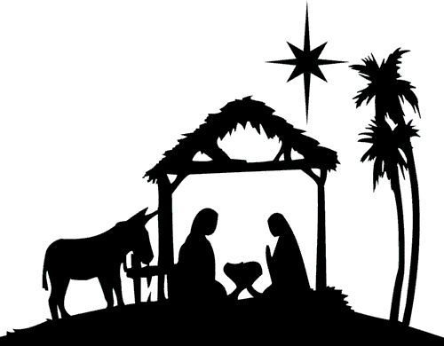

December 17, 2015
5:30 pm - 7:00 pm

